Requirement Analysis

Group LTU13B.02

* Trần Lê Hoàng
* …

# Use case diagram

## General use case diagram

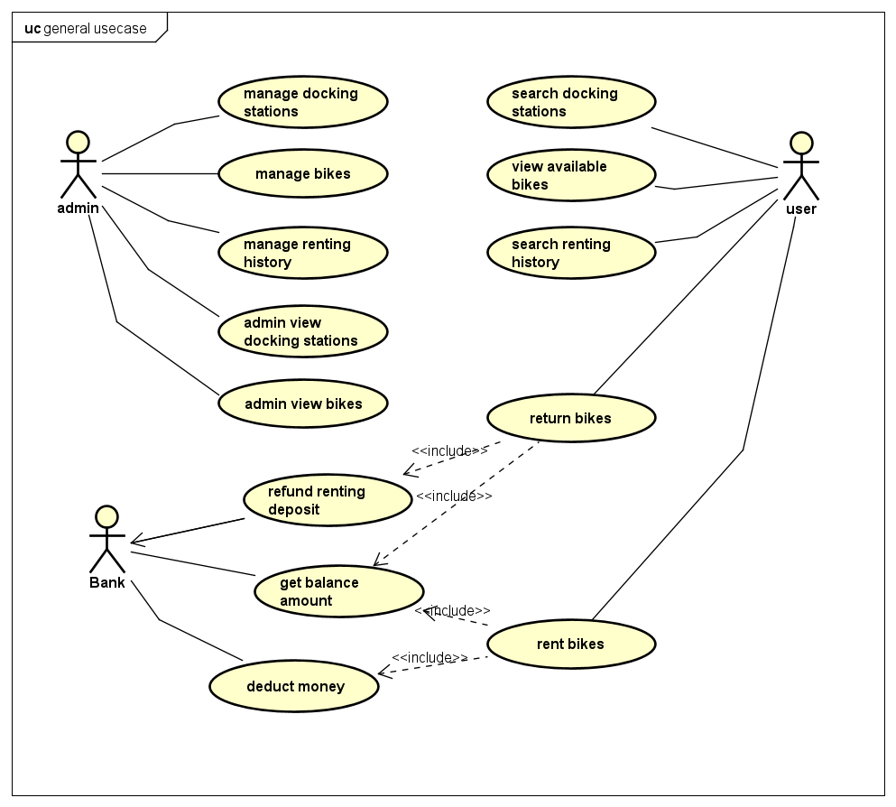

Explanation:

Composite use case:

* Manage docking stations
* Manage bikes
* Manage renting history
* Rent bikes
* Return bikes

## Use case diagram for “Manage docking stations”

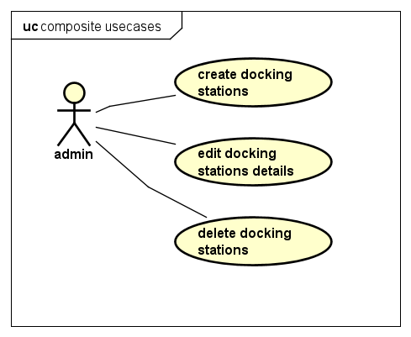

## Use case diagram for “Manage bikes”

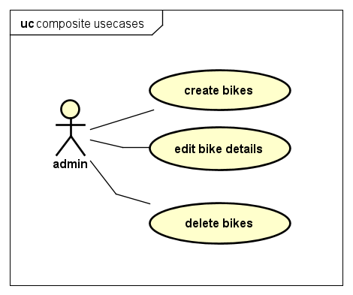

## Use case diagram for “Manage renting history”

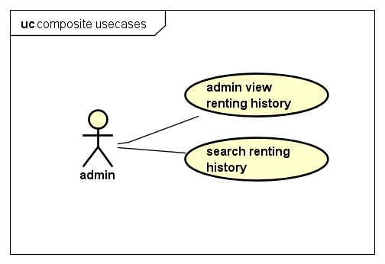

## Use case diagram for “Rent bikes”

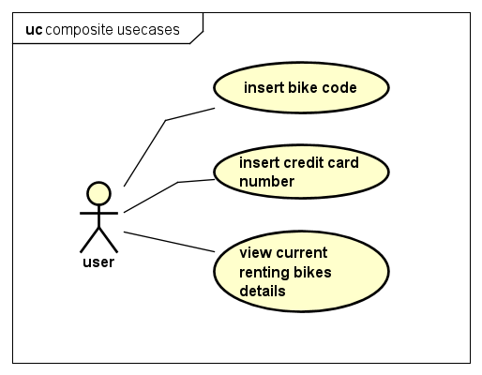

## Use case diagram for “Return bikes”

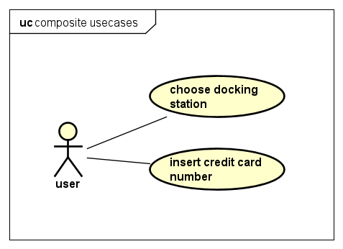

# Use case specification

## Use case “Edit bike details”

|  |  |  |  |
| --- | --- | --- | --- |
| UC Code | UC001 | Use case name | Edit bike details |
| Actor | Admin | | |
| Description | The “edit bike details” use case is initiated when admin press edit button in the list of bikes in docking station page. Subsequently, a new page with title “Update bike details” appears containing current information about the selected bike. Admin can then edit each individual fields. The page can be dismissed by clicking either “Save” or “Cancel” button. Pressing “Save” button will result in the entry of selected bike be updated to reflect changes, while “Cancel” button made no changes to the bike list | | |
| Precondition | Admin successful Login | | |
| Main flow of event (success) | | # | Doer | Action | | --- | --- | --- | |  | Admin | Choose edit bike button in bikes page | |  | Software | displays admin edit bike screen | |  | Software | Update details in edit screen with selected bike | |  | Admin | enters bike details to update | |  | Admin | Choose save bike button | |  | Software | checks if the entered detail fields is valid | |  | Software | Save updated bike if details is valid | |  | Software | Displays successfully update bike detail message | |  | Software | Close edit page and return to bike list page | | | |
| Alternative flow of event | |  |  |  | | --- | --- | --- | | # | Doer | Action | |  | Admin | Cancels edit page at any time | | 4a | Admin | Clears any field before saving | | 5b | Admin | Choose cancel button | | 6a. | Software | Notifies error “Invalid field input” if the entered detail field is invalid, go to step 2 | | 6b | Software | Notifies information “No field change” if nothing is edited, go to step 2 | | | |